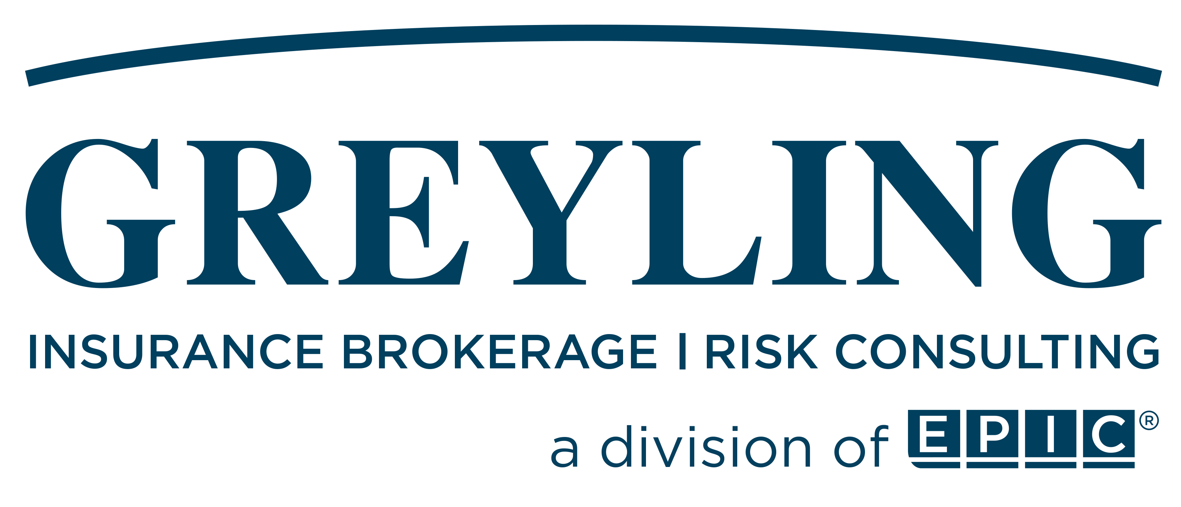

Project
Project Specific: I-95 (SR 9) from South of SR 126 (Emerson St.) to SR 10 (Atlantic Blvd.)
WGI, Inc.
Primary Named Insured

Policy Period: July 8, 2023-July 8, 2027

Account Executive: Kristen Walker
Broker: Aaron Lavespere
Meeting Date: 07/10/2023

Table of Contents
Insurers Approached 3
Project Details 4
Program Summary 7
Detailed Insurer Proposals 8
Professional Liability 8
Payment Options 9
Greyling Service Team 10
Appendix 11
Explanation of A.M. Best Rating Information 11

Insurers Approached

Greyling Insurance Brokerage negotiated with the insurers listed below on behalf of WGI to obtain proposals for:
- Primary Project Specific Professional Liability (PSPL)
- Excess Project Specific Professional Liability (PSPL)
A summary of their responses is provided below.
Insurer | Coverages | Status
AIG | Excess PSPL | Declined
Allianz | Excess PSPL | Declined
Allied World | Primary PSPL | Quoted – Terms Included
Arch | Excess PSPL | Declined
Aspen | Excess PSPL | No Response
Berkshire | Excess PSPL | Declined
CNA | Excess PSPL | Declined
Everest | Excess PSPL | Declined
Sompo | Excess PSPL | Declined
Starr | Primary PLPL  Excess PSPL | Quoted - High  Quoted – Terms Included
Swiss Re | Excess PSPL | Declined
Vantage | Excess PSPL | Indicated - High

Project Details

Project Name: | I-95 (SR 9) from South of SR 126 (Emerson St.) to SR 10 (Atlantic Blvd.)
Location: | Jacksonville, Duval County, Florida area region
Project Owner: | Florida DOT (District 2)
Contract: | E220-122-B
Description of Project: | DB project for FDOT District 2 (Jacksonville Area Region) located within Jacksonville, FL. This project will widen I-95 from south of Emerson St to south of Atlantic Ave, along I-95. The project length is approximately 1.5-miles. The project includes two bridge replacements and one interchange reconstruction.
Primary Named Insured: | WGI, Inc.
Named Insured Address: | 2035 Vista Parkway, West Palm Beach, FL 33411
Named Insured Contact: | Rey Rivas  407.581.1221 (office)|786.299.0247 (cell)  Rey.Rivas@wginc.com
Additional Named Insureds: | Arcadia U.S., Inc.  Tierra, Inc.  Rummel, Klepper & Kahl, LLP
Contractor: | Superior Construction Company Southeast, LLC
Estimated Hard Construction Values: | $247,160,000
Estimated Design Fees: | $19,533,671
Project Specific Professional Liability Insurance Requirements from Prime Design Contract: | $10,000,000 Per Claim / $10,000,000 Aggregate  6.4 Premium for Project Specific Professional Liability Insurance.  6.4.1 The Project Specific Professional Liability Insurance (“PSPLI”) Fee provided for bidding  included an indication of ONE MILLION THREE HUNDRED TWO THOUSAND AND ZERO/100  DOLLARS ($1,302,000.00). Design-Builder shall pay Design Consultant the amount specified  above within ten (10) working days after Design-Builder's receipt of payment for the PLPSI from  the Owner.  The certificates of insurance for all coverages enumerated above must contain the provision that: “The coverages afforded will not be canceled or materially changed until at least thirty (30) day’s prior written notice has been given to Design-Builder.”

Practice Professional Liability Insurance Requirements from Prime Design Contract: | $5,000,000 Per Claim / $5,000,000 Aggregate
Limitation of Liability: | 11.8 LIMITATIONS OF LIABILITY.  11.8.1 Design-Builder agrees that to the fullest extent permitted by law, and notwithstanding any  other provision of this Agreement, the total liability in the aggregate of Design Consultant, its  officers, directors, employees, agents, and subconsultants, to Design-Builder and anyone claiming  by, through, or under them for any and all claims, damages, losses, liabilities, costs, or damages  whatsoever arising out of, resulting from, or in any way related to the Project or this Agreement  from any cause, including but not limited to the negligence, professional errors or omissions, strict  liability, breach of contract, indemnification claims, or warranty (express or implied) of Design  Consultant or its officers, directors, employees, agents, or subconsultants, shall not exceed the  policy limits of the PSPLI (the project specific professional liability policy required under this  Agreement), plus Five Million Dollars ($5,000,000.00). This aggregate limitation of liability is  inclusive of the sub-limit for delay damages set forth in Section 11.8.2 herein. The parties agree  that adequate compensation has been given for this limitation.  11.8.2 Design-Builder agrees that to the fullest extent permitted by law, and notwithstanding any  other provision in this Agreement, the total liability of Design Consultant, its officers, directors,  employees, agents, and subconsultants, to Design-Builder and anyone claiming by, through, or  under them for any and all delay, acceleration, lost milestone payment or bonus, disincentive,  liquidated damages, and other schedule-related claims, damages, losses, liabilities, costs, or  damages whatsoever arising out of, resulting from, or in any way related to the Project or this  Agreement from any cause, including but not limited to the negligence, professional errors or  omissions, strict liability, breach of contract, indemnification claims, or warranty (express or implied)  of Design Consultant or its officers, directors, employees, agents, or subconsultants shall not  exceed, in the aggregate, twenty-five percent (25%) of the amount of the Design Consultant Fee  actually paid to Design Consultant. In order for Design Consultant to be liable for delay damages,  the delay damages must be only to the extent caused by Design Consultant’s failure to comply with  the mutually-agreed Design Schedule, and any timely provided schedule updates in accordance  with Sections 1.5.4 and 3.3.5, and the critical path for the Project. This limitation of Design  Consultant’s liability for delay damages is a sub-limitation included within the aggregate limitation  of Design Consultant’s liability set forth in Section 11.8.1, above.

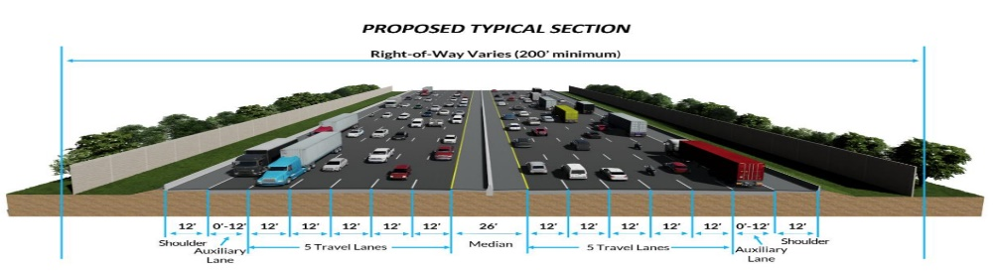
https://nflroads.com/StorymapFrame.aspx?ProjectName=I95-JTBtoATL&sid=77c093cc33cf4a6d88fbda0617150e29

Program Summary

Layer | Insurer | Limit | Retention | Premium + Tax
Primary | Allied World | $10,000,000 | $500,000 | $1,302,000
1st Excess
2nd Excess
3rd Excess
Fee
 |  | $10,000,000 | $500,000 | $1,302,000

Detailed Insurer Proposals

Professional Liability
Insurer: | Allied World Surplus Lines Insurance Company
Policy Number: | TBD
A.M. Best: | A+: XV
Policy Form: | PS 00002 00 (03/16)
Policy Period: | 07/08/2023 – 12/30/2027
Coverage Trigger: | Claims-Made
Retroactive Date: | 12/12/2022
Extended Reporting Period: | 4 Years
Limits of Liability: | $10,000,000 per claim  $10,000,000 aggregate
Deductible: | $500,000 per claim
Premium: | $1,240,000
Surplus Lines Tax: | Project State Florida: 4.94%  $61,256
Stamping Fee: | Project State Florida: 0.06%  $744
Total: | $1,302,000
Minimum Earned: | 100%
Audit Terms: | Auditable 10% of CVs and 10% of fees  Audit Terms: Policy is subject to audit at expiration based on rate of $19,533,671 applied to the final Construction Values/Fees in excess of $21,487,038 (10% buffer)
Subjectivities: | - Signed and dated application  - Surplus lines policy information form
Comments: | - N/A
Terms & Conditions: | - Policyholder Notices  - State Amendatory  - Material Variation/Project Tracking  - 30 Day Notice of Cancellation

Payment Options

The following options are available for paying the premium:
- Pay Full Premium within 15 Days of Invoice Date: Payment made through Greyling Insurance Brokerage.
  - Binding Effective October 15,2023 with a construction start date of February 2024
  - Premium will be due by October 20,2023
- Premium Finance: Available with the following caveats:
  - Financial Solvency of the Insured.
  - Additional financial data or guarantees may be required.
  - Additional collateral may be required by financing other policies.

Greyling Service Team

 | Team Member |  |  | Role |  | Contact Information
 |  | Leo Argiris, PE  Executive Managing Principal | Senior Client Advisor |  | D: (678) 824-8568  M: (646) 642-7163  E-Mail: Leo.Argiris@greyling.com
 |  | Kristen Walker  SVP, CRIS  LEED Green Associate | Client Executive  (main contact with overall account responsibility) |  | Office Phone: (770) 220-7691  Cell Phone: (770) 508-0808  E-Mail: Kristen.Walker@greyling.com
 |  | Sally Bright, J.D. | Complex Claims, Contract Review, Risk Management, Back-up Client Executive |  | Office Phone: (470) 305-1384  Cell Phone: (404) 931-3763  E-Mail: Sally.Bright@greyling.com
 |  | Aaron Lavespere  Vice President | Broker  (day-to-day service,  support for client executive) |  | Cell Phone: (603) 494-1466  Email: Aaron.Lavespere@Greyling.com
 |  | Sharon Brubaker | Insurance Certificate Specialist |  | Office Phone: 770-756-6599  E-Mail: sharon.brubaker@greyling.com
 |  | Erin Maurer, CIC, CRM | Policy Manager  (checks policies, verifies documentation, and develops coverage specifications) |  | Office Phone: (770) 552-4225  E-Mail: Erin.Maurer@greyling.com
 |  | Winnie Chan | Accounting |  | Office Phone: (770) 220-7682  E Mail: Winnie.Chan@greyling.com

Appendix

Explanation of A.M. Best Rating Information
Financial Strength Ratings
A.M. Best's Financial Strength Rating (FSR) is an opinion of an insurer's ability to meet its obligations to policyholders. Rating Modifiers and Affiliation Codes may also be associated with these ratings. The following list outlines our rating scale and associated descriptions.
Secure | Vulnerable
A++, A+ (Superior) | B, B- (Fair)
A, A- (Excellent) | C++, C+ (Marginal)
B++, B+ (Good) | C, C- (Weak)
 | D (Poor)
 | E (Under Regulatory Supervision)
 | F (In Liquidation)
 | S (Rating Suspended)
Ratings Outlook
Assigned to an Interactive Financial Strength Rating (A++ to D) to indicate the potential direction over an intermediate term, generally defined as 12 to 36 months.
Positive | Indicates possible rating upgrade due to favorable financial/market trends relative to the current rating level
Negative | Indicates possible rating downgrade due to unfavorable financial/market trends relative to the current rating level
Stable | Indicates low likelihood of rating change due to stable financial/market trends.

Financial Size Categories (FSC)*
To enhance the usefulness of our ratings, A.M. Best assigns each letter rated (A++ through D) insurance company a Financial Size Category (FSC). The FSC is designed to provide a convenient indicator of the size of a company in terms of its statutory surplus and related accounts.
Many insurance buyers only want to consider buying insurance coverage from companies that they believe have sufficient financial capacity to provide the necessary policy limits to insure their risks. Although companies utilize reinsurance to reduce their net retention on the policy limits they underwrite, many buyers still feel more comfortable buying from companies perceived to have greater financial capacity.
FSC | Adjusted Policyholder’ Surplus |  | FSC | Adjusted Policyholder’ Surplus
I | Less than 1 |  | IX | 250 to 500
II | 1 to 2 |  | X | 500 to 750
III | 2 to 5 |  | XI | 750 to 1,000
IV | 5 to 10 |  | XII | 1,000 to 1,250
V | 10 to 25 |  | XIII | 1,250 to 1,500
VI | 25 to 50 |  | XIV | 1,500 to 2,000
VII | 50 to 100 |  | XV | 2,000 or greater
VIII | 100 to 250

Note: Ranges are in millions of U.S. dollars

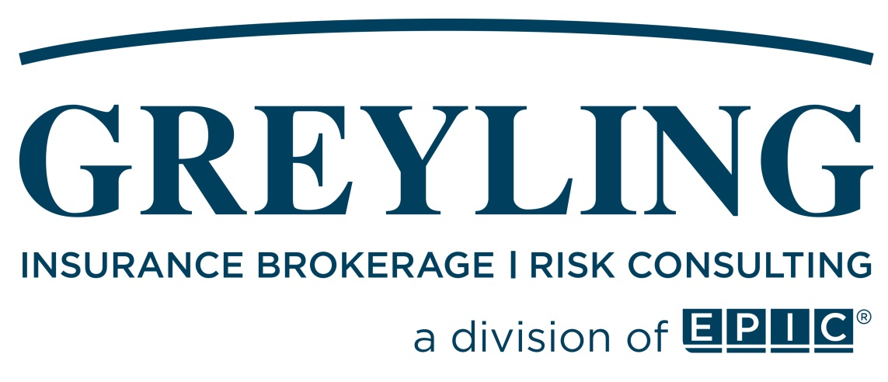

Phone: | (877) 908-5619
Fax: | (866) 550-4082
Email: | info@greyling.com

Disclaimer: This report is not a legal contract. The coverage summaries are intended to provide a brief overview of the terms, conditions, limits, and premiums of the insurance coverages described. The information in this report may not be used in adjusting or adjudicating any loss. This report does not grant or bind coverage and is not intended to serve as evidence of coverage in place. It is meant solely to provide you with a brief synopsis. For detailed and accurate information about the coverages provided, you must read the actual policies.
The coverages we have placed for you are based on our understanding of your operations. We rely on you to provide us with the necessary information to provide appropriate policies and coverages. It is your responsibility to advise us of your operations, including any changes, such as (but not limited to) operations in new states, new services provided to your clients, new vehicles or equipment, and new property locations.

